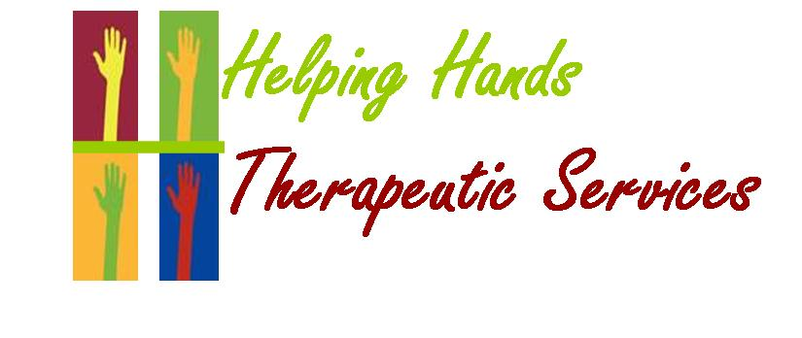

Helping Hands Therapeutic Services, LLC
Baltimore
Maryland

Strategic Plan for 2020-2023

Reviewed on 1/1/2020 by Babajide Saba, Peter Mwangi, Elizabeth Kamau, and Vivian Kamau

Purpose

This document provides an overview of the vision for the future of mental health services provided by Helping Hands Therapeutic Services, LLC over the next three years and establishes key priority goals and objectives to be completed in 2017 to support that vision. This plan is not meant to be stationary; the goals and objectives in this document will continue to be updated and modified based on the changing landscape of mental health needs, input we receive from stakeholders as we implement our action steps, and specific data that we collect to evaluate the effectiveness of our implementation.
Sources of Input and Information
In preparation for the creation of this strategic plan, HH has included input from the following: Owner, CEO, Advisory Board, PRP Program Director, staff, patients and independent research sources, to identify the:
- Unmet needs of the Maryland population
- Strengths of our agency and services currently provided
- Weaknesses of our agency and services currently provided
- Opportunities to expand and improve our mental health services
- Current and future threats that may impair our ability to support individuals and families with mental health needs
- Innovative and evidence-based approaches and models to providing and supporting mental health services.
Guiding Principles
The development and implementation of this strategic plan will be guided by the following principles:
- HH will include patients, patient’s families, patient’s peers, other providers, and community and state contributors in the planning, development and provision of the activities, services and supports referenced in this plan.
- HH will collect and use reliable data to demonstrate the achievement of our strategic goals.
HH will continue to support mental health care that is:
- Person and family-centered
- Focused on recovery and resiliency
- Supportive of individual choice and self-determination
- Based on evidence of improved individual and family outcomes

Maryland Mental Health Model
HH’s vision for the future of mental health services in Maryland will also incorporate the values defined in the State of Maryland, “2017 ANNUAL STATE MENTAL HEALTH PLAN”.

The values underpinning this system are:
(1) SUPPORTIVE OF HUMAN RIGHTS
Persons with psychiatric and/or substance use disorders have the same rights and obligations as other citizens of the state. Consumers have the right to choice, to retain the fullest possible control over their own lives, and to have opportunities to be involved in their communities.

(2) RESPONSIVE SYSTEM
The behavioral health system of care must be responsive to the people it serves, coherently organized, and accessible to those individuals needing behavioral health care. Information must be readily available for individuals to enter and proceed through the system in a more appropriate and timely manner. The hospitals are one part of the community-based behavioral health system of care. The behavioral health system of care must collaborate with other public and private human health service systems in order to allow for continuity of care and facilitate support with all activities of life.

(3) EMPOWERMENT
Consumers, families, and advocates will be involved in decision-making processes, individually at the treatment level and collectively in the planning and operational aspects of the behavioral health system. An array of services and programs must be available to allow for consumer choice in obtaining and using necessary services. Relevant programs and services that recognize varying cultural, ethnic, and racial needs are imperative.

(4) COMMUNITY EDUCATION
Wellness is promoted and enhanced through early identification and prevention activities for risk groups of all ages. Public education and efforts that support families and communities must be incorporated into our service system. Increased acceptance and support for behavioral health services come from increased awareness and understanding of psychiatric and substance use disorders and treatment options.

(5) FAMILY AND COMMUNITY SUPPORT
We must provide families with the assistance they need in order to maintain or enhance the support they give to their family members. We will strive to provide services to persons within their communities with the availability of natural/family supports.

(6) LEAST RESTRICTIVE SETTING
An array of services will be available throughout the state to meet a variety of consumer needs. These services should be provided in the least restrictive, most normative, and most appropriate setting.

(7) WORKING COLLABORATIVELY
Collaborations with other agencies at the state and local level will be fostered so support to consumers is inclusive in all activities of life. This will promote a consistently appropriate level of behavioral health services.

(8) EFFECTIVE MANAGEMENT AND ACCOUNTABILITY
Accountability is essential to consistently provide an adequate level of behavioral health services. Essential management functions include monitoring and self-evaluation, rapid response to identified weaknesses in the system, adaptation to changing needs, and improved technology. We must put the highest priority on measuring consumer satisfaction with the services they receive. Outcome measures will be a key component for evaluating program effectiveness.

(9) LOCAL GOVERNANCE
Local management of resources, resulting from the implementation of Core Service Agencies, will improve continuity of care, provide needed services in a timelier manner, improve the congruence of services and resources with needs, and increase economic efficiency due to the closer proximity of the service delivery level.

(10) STAFF RESOURCES
The presence of a competent and committed staff is essential for the provision of an acceptable level of behavioral health services. Staff must be provided with adequate support systems and incentives to enable them to focus their efforts on the individuals who receive care from them. Opportunities must be provided for skill enhancement training or retraining as changes in the service system take place.

Vision, Priority Goals and Objectives
Using our guiding principles and the public health model as our framework, HH has established the following vision, priority goals and objectives to achieve our vision:
VISION
Helping Hands Therapeutic Services: striving to be the leader in authentic mental health treatment by way of our caring staff and comprehensive services. For us, true success is measured by the success of the clients we serve.

PRIORITY GOALS: 2020-2023
Over the next three years, HH will implement strategies that:
- Promote mental health and wellness for all Maryland residents
- Protect the public from the risks for mental health disorders
- Intervene early to treat mental health problems
- Provide support and treatment to achieve recovery and resiliency

Through the implementation of these goals, HH will strive to use and increase the availability and quality of person and family-centered, evidence-based interventions focused on achieving specific individual, family, and population-based outcomes.

PROCESSES FOR COLLECTING EVIDENCE BASED PLANNING DATA

- Collection of information through employee surveys
- Collection of information through patient surveys
- Collection of information through stakeholders surveys
- Collection of information through suggestion box
- Collection of information through Advisory Board meeting

OBJECTIVES TO BE COMPLETED in 2020
To achieve the goals described above, HH has established the following objectives to be completed during the calendar year 2017:
1. To obtain CARF accreditation for a three-year period beginning fall of 2017 through fall 2020. (Priority Goal)
2. To hire additional medical provider(s) (Priority Goal)
3. To improve the day-to-day operations of HH by way of methodical trainings and education
4. The addition of a benefits package for employees
5. Begin process of adding certified addictions treatment

Goal 1: To hire additional medical provider(s)

Rationale: HH has the opportunity for exponential growth. Our foundational leadership has experienced stability over the past 12 months and continues to grow stronger each day. With the addition of medical providers, our company has the potential for considerable growth.

STRATEGIC ACTIONS:

- To contact local psychiatric providers to seek collaboration and possible mergers
  - Timeframe: January 2020 – Ongoing
- To advertise quarterly for job opportunities with HH
  - Timeframe: Continuous
- To contact local educational institutions for new psychiatric medication providers
  - Timeframe: Continuous

Goal 2: Begin process of adding certified addictions treatment.

Rationale: The reason why we are exploring addiction services is because mental health and addictions often go hand in hand. Within our practice we have seen the need for specialized addiction services. By adding these services, we hope to improve our overall comprehensive treatment services.

STRATEGIC ACTIONS:
- HH will continue to work with the Core Service Agency of Baltimore City to discuss the process for becoming a certified addictions counseling provider.
  - Timeframe: December 2020
- HH will send its staff to CARF training to learn the processes of being certified for addiction services.
  - Timeframe: December 2020

- HH will then submit the application to DHMH upon becoming knowledgeable about the process for certification.
  - Timeframe: December 2021

Goal 3: To improve unity among staff within program.

Rationale: HH would like to improve the overall working relationship between staffs. HH notices that the best of employees are brought out when there is improved cohesion among coworkers. Our hope is that this will ultimately improve the quality of care for our clients and employee satisfaction.

STRATEGIC ACTIONS:
- HH will continue to create team building activities for its employees in various settings.
  - Timeframe: December 2020
- HH will continue to provide group activities for our patients.
  - Timeframe: December 2020

- HH will explore travel destinations for team building purposes.
  - Timeframe: December 2020

